Creative Spark
Higher Education Enterprise Programme

Createathon – Student Manual



Participant Name

Contents

Name:

Before you start the programme, we want you to take a few minutes to note some of your ambitions for taking part in this programme
Personal Goals

Take a note of how you feel at this point.

Feelings

Day 1 - Monday 13th June
The workshop largely comprises practical activities, in which the teams are given specific tools to apply to tasks and the time to go into breakout spaces and work as a team. The student teams will be working directly with their creative enterprise.
This 2-day Programme is an intensive, active learning experience, where you will work as a team and be mindful of keeping to time. In Day 1 there are a number of sessions, and we provide some brief details about these below. The information is deliberately brief as the method of learning is through active engagement, debrief and reflection activities.
Day 1: Workshop Schedule

Students and Creative Enterprises | Time | Location
Introduction and Welcome | 11:00 | Main Room
Activity 1: Creativity Warm Up | 11.15 | Main Room
Creative enterprises & student teams:  - Activity 2: Enterprise Storytelling  - Activity 3: Personal Values Exercise  - Activity 4: Creating a Problem Statement | 11.45  12.30  12.45 | Breakout Rooms
Lunch | 13.00
Introduction to Creative Business Model Canvas (CBMC) | 14.15 | Main Room
Activity 5: Developing the Creative Business Model Canvas | 14.25 | Breakout Rooms
Tea break | 15:30
Progress Update & Introduction to Activity 6 | 15:45 | Main Room
Activity 6: ‘What would success look like?’ exercise | 16:00 | Breakout Rooms
Wrap Up and Next Steps | 16.45 | Main Room

Introduction and welcome
The introduction session will give you an overview of the Creative Spark Programme, involving the Center Analysis of Economic Reforms & Communications and Newcastle University Business School. Here, you will meet educators from the Creative Spark project and from across various locations in Azerbaijan. We will also provide an overview of the day 1 activities.

You will take part in the following activities in Day 1:

- Creativity Warm-Up
- Enterprise Storytelling
- Personal Values Exercise
- Creating a Problem Statement
- Developing the Creative Business Model Canvas
- What would success look like?

Activity 1: Creativity Warm-Up

Purpose:
There is no better way to start the ideation process than to engage in some creativity games and to get to know your team and the creative enterprise you are working with.

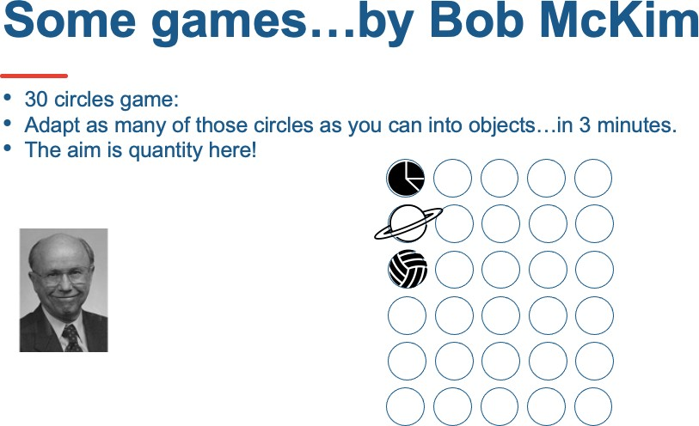

Activity 2: Enterprise Storytelling

Purpose:
This is an opportunity for you to hear the story of the creative entrepreneur and their enterprise. We recommend the student team lead this conversation and ask questions of interests to gain insights into the motivation of the entrepreneur and a snapshot as to where the enterprise is presently, in relation to the challenge that they have

Preparation:
You may wish to develop some questions under these key headings:

- Origin of the business and people involved in this business.
- Background of the founder of the creative enterprise.
- Significant incidents in the enterprise’s history.
- Product and/or services in the creative enterprise’s current portfolio.
- Current customer and revenue streams.
- The origin of the challenge set for the Createathon.

Activity 3: Personal Values Exercise

Purpose:
In this exercise the student teams are going to capture and organise their client’s personal values. What makes the business owner feel passionately committed to what they are doing in their business?

Format:
The teams will use the Values Exercise template to synthesise findings from the Business Brief and your conversations on the day. Students should ask them to consider what is:

- Always important
- Sometimes important
- Rarely important
- Never important

Activity 4: Creating a Problem Statement

Purpose:
In this context, a Problem Statement is a way of describing the gap between where the creative enterprise is at present and where they want to be after the Createathon. The creative enterprise has established where they want to be through their challenge brief and through the storytelling exercise the teams have established where the creative enterprise is at present. Creating a Problem Statement aids analysis of the creative enterprise challenge and will help the team consolidate all assumptions and act as a touch point to test any potential solutions for the ongoing process of designing a solution for the company challenge. It is important to remember however that solutions are not proposed at this stage.

Format:
Students should describe what is the challenge faced by the enterprise at this stage and where the enterprise wants to be by the end of the Createathon.
- The challenge of (describe the challenge) .
- Affects (who is affected by the problem) .
- The impact of which is (what is the impact of the challenge) .
- A successful solution would (list some key benefits of a successful solution, ensuring that you have considered the personal values of your creative enterprise) .

DRAFT YOUR PROBLEM STATEMENT

Introduction to the Creative Enterprise Canvas

Purpose:
The Creative Enterprise Canvas is an adaptation of the more well-known Business Model Canvas, which presents a visual overview of the 9 components of a business on one page and is:
- A strategic management and lean start-up template for developing new OR documenting existing business models.
- A visual chart with elements describing a firm’s value proposition, infrastructure, customers and finances.
- A tool to assist in testing and aligning business activities.

Format:
There is a very helpful short video https://www.youtube.com/watch?v=QoAOzMTLP5s

This video should help you understand the task quickly: https://www.youtube.com/watch?v=wlKP-BaC0jA

- Value Proposition - what does your business offer and what benefits do your products/services offer customers?
- Customer Segments - who will use/purchase your products or services?
- Distribution Channels - how will you reach your customers and offer them your value proposition?
- Customer Relationships - how will you acquire and retain customers?
- Revenue Streams – what revenue streams are generated by your value proposition(s)?
- Key Activities – what tasks do you need to carry out in order to fulfil your business purpose?
- Key Resources - what are the main inputs you need to create your value proposition, service your customer segment and deliver the product to your customer?
- Key Partners – who are the partners you need to enable you to perform your key activities?
- Cost Structure – what are the costs of delivering your value proposition?

The Creative Enterprise Canvas
(8) Key partners
Who do we need to collaborate with/partner with?

What do we need to share?

Who can help us deliver the business or project?
(7) Key activities
What do we need to do to deliver the value to our audiences/customers?
(2) Value Creation
What unique experiences, services or products are we offering to our audiences/customers?

Which of our audiences/customers problems are we trying to solve?

What are we helping audiences/customers to achieve?

What audiences/customers needs and interests are we helping to satisfy?

What are we creating which is valuable to our customers/audiences?
(4) Audience/Customer relationships
What type of relationship do we need with our audiences and customers?
How can we connect, develop and maintain relationships with audiences/customers?
(9) Funds Out (Cost Structure)
What are the important costs you make
to create & delivery your value proposition?

(3) Channels
How do we reach each of our different audiences/customer groups?
How do we communicate our offer?
How do we deliver our creative product
(6) Key resources
What resources do you need to make our idea work?
Intellectual/creative? People?
Physical? Financial? Technical?
(1) Customer groups
Who are our most important audiences/customers?

Who will be interested in our experiences, services or products?

How can we understand groups of customers and identify their needs/interests?
(5) Funds In (Revenue Streams)
How do customers reward you for the value you provide to them? What are the different revenue models?

Source: Adapted from Strategyzer.com

notes & questions

Activity 5: Developing a (Creative) Business Model Canvas

Purpose:
The CBMC should be completed focusing on the sections relevant to the enterprise’s priorities.

Note: If the creative enterprise finds it challenging to define the benefits they offer to their customers/clients then it could be useful to use the Value Proposition Canvas first (see below).

Here we link to a very brief overview of the Value Proposition Canvas on YouTube - https://www.youtube.com/watch?v=aN36EcTE54Q .

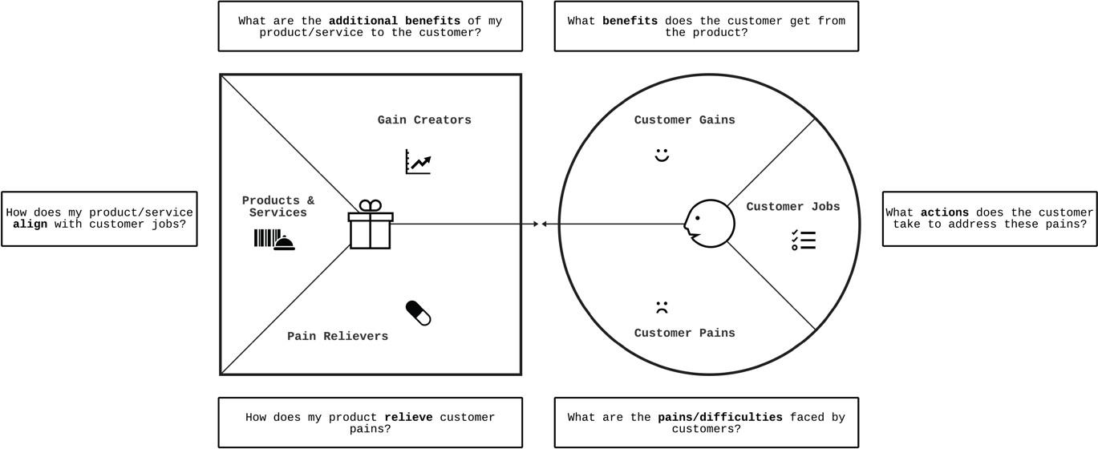

Source: Adapted from Strategyzer.com

Action 6: What would success look like?
Success in business means something different to each individual entrepreneur and getting the students to explore this topic with their business owner is essential so they can glean further insights into the specific Createathon business challenge and what it would mean if the challenge was successfully addressed. It is part of the information gathering stage, so the students can frame the recommendations that they are going to be working on to fit the entrepreneur’s vision of developing their enterprise.

Key areas to discuss with their entrepreneur are:
  - What are their ambitions for their business/this project? (encourage them to think as big as possible)
  - What impact could it have on their customers, on society, on the environment?
  - What impact could successfully achieving the challenge have on their own life and work?

Success should align with the entrepreneur’s personal values.

  - Could someone who was addressing childhood literacy demonstrate they had helped one million kids to read?
  - Could a fashion designer be featured on the front cover of a top fashion magazine?
  - Could a film maker win an Oscar for their work?
  - Could they make a 1 million or 100 million £/€/$ from their product or service?
  - Could they employ 100 people?

Student teams should create a visual representation (draw it!) of what success would look like for their business client.

draw it!

Wrap up and Next Steps

Key homework action for students:
Tomorrow you will be presenting the ideas for your solutions to the client’s challenge. The presentation to the client takes the form of a Pecha Kucha.

A Pecha Kucha is a 20x20 presentation format with 20 slides (mainly using images), each shown for 20 seconds.

We have prepared some resources to start you off and provided an Animated PowerPoint slide deck. You will need to create your own Pecha Kucha presentation and whilst we will brief you on this tomorrow, we thought you might like to be prepared with what you will create for your client.

Tomorrow you will prepare your team’s Pecha Kucha presentation. Students can use these video resources and more are available online.

- Leanne Robinson-Maine - Top Tips for Pecha Kucha Presenters Do you want to know more? https://www.youtube.com/watch?v=5df7XtyvDb4 (Links to an external site.)
- Brian Scott Peterson, Pecha Kucha's Global Dude at PKHQ in Tokyo, has watched literally 1000's of Pecha Kucha Presentations. He has given quite a few as well and thinks he knows, from lots of experience and a birds-eye view from headquarters what makes a truly great Pecha Kucha Presentation. Do you want to know more? http://www.youtube.com/watch?v=JlcDz4kLck8 (Links to an external site.)

- Pecha Kucha about Pecha Kucha, by Hans Van de Water
A world without boring PowerPoint presentations? It is possible! In this video public speaking mentor, Hans Van de Water (The Floor is Yours) explains to you what Pecha Kucha is about and how it works. Do you want to know more? https://www.youtube.com/watch?v=gZJc8PB2DsQ (Links to an external site.)

Students should not be using any images that are subject to copyright.

Please use free images, we recommend: Unsplash2, - make sure you select ‘free images’ and acknowledge the producer, wherever possible.

Day 2 – Tuesday 14th June 10am – 5pm
Day 2: Workshop Schedule
Students and Creative Enterprises | Time | Location
Introduction and Welcome | 10.00 | Main Room
Introduction to Pecha Kucha | 11.15 | Main Room
Activity 1: Student Teams  - Finalise Pecha Kucha  - Finalise action card recommendations |  | Breakout Rooms
Lunch | 13.00
Introduction to Day 2 for the Creative Enterprises | 14.15 | Main Room
Activity 2: Creative enterprises work with student’s teams -  Discussion of Pecha Kucha and action card recommendations | 14.25 | Breakout Rooms
Tea break | 15:30
Activity 3: Presentation of the Pecha Kuchas | 15:45 | Main Room
Feedback, Certificates presentation and close | 16.45 | Main Room

Introduction to Day 2 and to Pecha Kucha

Purpose:

In this session you will be guided through the expectations of the final day of the Createathon. Information for Pecha Kucha is located at the end of Day 1 activities on page , which facilitators will review briefly as part of a focus on ‘presentation top-tips’.

Teams will provide updates on their team’s work on developing their creative canvas and solutions to the challenge. Facilitators will assist with queries and supporting initial ideas for the developing the Pecha Kucha.

Activity 1 - Finalise Pecha Kucha presentations and Action Card recommendations

Purpose:
This is your opportunity to work independently, without help from entrepreneurs.

You will finalise your Pecha Kucha that you will present back, including:
- what you have learned about the business
- what success would look like for your client and
- outline your proposed solutions for the Createathon challenge
You will also complete an Action Card1 where recommendations and proposed solutions can be outlined in more detail.

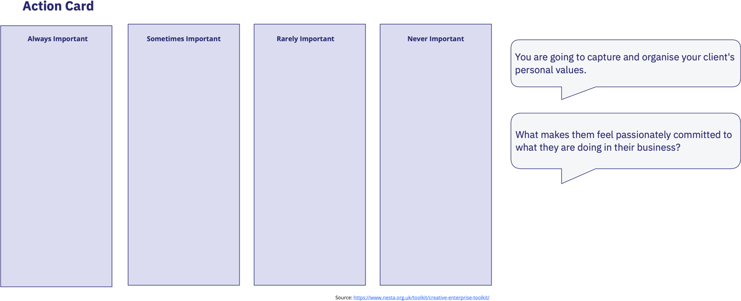

your notes

Activity 2 - Discussion of future and action card recommendations
After a welcome session in the main room the creative enterprises will join the student teams in their breakout rooms.
Students will rehearse their Pecha Kucha presentations and sense check for clarity and appropriateness of recommendations being proposed. This also gives the chance for the entrepreneur to ask and questions and give their initial feedback.
It is important at this stage for the students to check with their creative entrepreneur that they have their permission to share the presentation with all the participants of the Createathon – this gives the entrepreneur the chance to ensure that there is nothing in Pecha Kucha or recommendations that is confidential or that the entrepreneur does not want them to share with the wider event audience.

Any final amendments to the Pecha Kucha can be made collaboratively.

your notes

Activity 3 - Presentation of the Pecha Kuchas

Format:
Each team delivers their presentation on the template we have provided.
That template enforces the 20x20 format, so each presentation should last for 6 minutes and 40 seconds exactly!
There will be a running order for the student teams.

Takeaways
The businesses can be provided with a copy of their Pecha Kucha.
The students could also save their Pecha Kucha as a record of achievement, providing they have permission. These outputs can be used as evidence of entrepreneurial learning, demonstrating you have learnt new skills such as working in an interdisciplinary team, using customer-led design approaches and creative problem-solving skills, and the ability to work under pressure within tight timescales.

Wrap up session
Facilitators summarise key learning points from Day Two and answer any final questions from students and enterprises.
All participants will be asked to complete evaluation and feedback forms and students will receive a Certificate of Attendance
The session is closed with expressions of thanks and appreciation, including presentations of Certificate of Attendance for students and small tokens of thanks for all participants.

Next steps…
We would love to get in touch with you in the future to share any relevant opportunities and to follow you on your entrepreneurial journey! If you are happy to be contacted about this in the future, please email us with the email title: Stay in touch <YOUR NAME> to:
ADD EMAIL HERE

reflections

YOUR GOALS – NEXT STEPS

